ISSTracker Software Description

ISSTracker v1.0.0

Rami Houdroge

July 2013

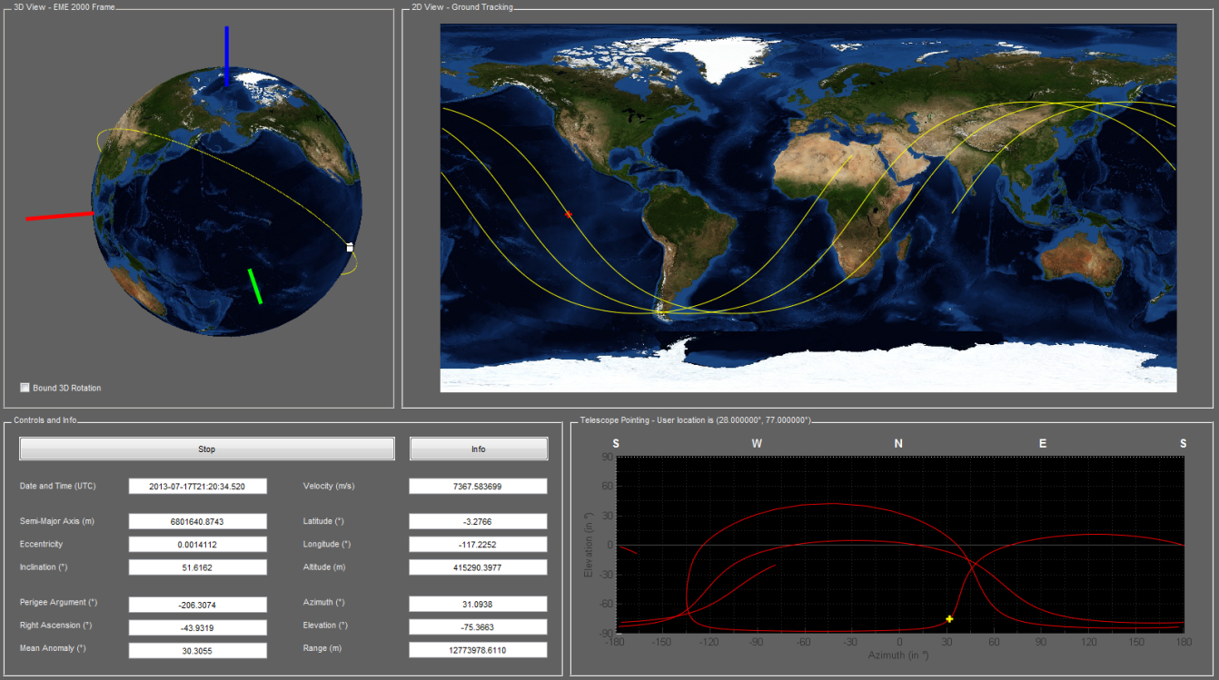

# Scope

The scope of this document is to present the real time International Space Station Tracker developed in Matlab.

# Acknowledgements

This project wouldn’t have been possible without the work of hundreds of men and women, whom I would like to thank most sincerely for making available to the general public an immense amount of scientific data and software. Parts and/or resources of the following projects were used in the development of this software:

1. OREKIT (ORbits Extrapolation KIT), C.-S. [***website***](https://www.orekit.org/forge/projects/orekit)
2. Apache Commons Math, Apache Commons [***website***](http://commons.apache.org/math/)
3. Solar System Dynamics, Jet Propulsion Laboratory, NASA [***website***](http://ssd.jpl.nasa.gov/)
4. Marshall Solar Activity Future Estimation, NASA [***website***](http://sail.msfc.nasa.gov/)
5. ISS orbital parameters, NASA Human spaceflight [***website***](http://spaceflight.nasa.gov/realdata/sightings/SSapplications/Post/JavaSSOP/orbit/ISS/SVPOST.html)
6. Blue Marble, Earth Observatory, NASA [***website***](http://earthobservatory.nasa.gov/Features/BlueMarble/)
7. International Center for Global Earth Models, IGFS and IAG [***website***](http://icgem.gfz-potsdam.de/ICGEM/modelstab.html)
8. Earth Orientation Center, OBSPM [***website***](http://hpiers.obspm.fr/eop-pc/index.php?index=leapsecond&lang=en)

# License

Copyright 2013 Rami Houdroge

Licensed under the Apache License, Version 2.0, January 2004; you may not use this file except in compliance with the License.

You may obtain a copy of the License at

http://www.apache.org/licenses/LICENSE-2.0

Unless required by applicable law or agreed to in writing, software distributed under the License is distributed on an "AS IS" BASIS, WITHOUT WARRANTIES OR CONDITIONS OF ANY KIND, either express or implied.

See the License for the specific language governing permissions and limitations under the License.

# Table of Contents

Scope i

Acknowledgements i

License i

Table of Contents ii

1 Introduction 1

2 Required 1

3 First run 1

4 Package Contents 2

5 Software Architecture 3

6 Dynamic Model 3

6.1 Forces 3

6.2 Frames 3

7 Prediction Accuracy 4

8 Future Features 5

# Introduction

The purpose of this open-source software is to provide Matlab users with the means to track the ISS in real-time, and to provide them with:

* Real-time Keplerian orbital parameters,
* Real-time 3D visualisation of the location of the ISS,
* Ground trace and real-time 2D location of the ISS,
* Real-time telescope pointing coordinates from a given user location.

This is done by propagating the orbit bulletin provided by Nasa. The ISS 24h ephemeris data ‎[R5] is regularly updated, and provides expected positions and planned manoeuvres for two weeks.

The low-level libraries Commons-Math and Orekit are used directly within Matlab to propagate the orbit bulletin and a Matlab Guide figure updated every 10 ms displays the real-time data.

# Required

Matlab (No toolboxes required).

An internet connection.

A good pc…

# First run

Just run the ISSTracker script.

A warning dialog that says “Loaded required libraries” will pop up. This is due to the fact that the commons-math3 and Orekit libraries need to be loaded prior to launching the ISSTracker. The warning box will load these libraries and the button “Run ISSTracker again...” will run the GUI.

A fix for that issue will be proposed in future versions.

# Package Contents

The ISSTracker zip file is available on the Mathworks file exchange.

Upon extraction, the following files and folders are created:

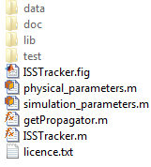

The *data* folder holds all the data files used to propagate the orbit bulletin, such as the gravitational coefficients files, the planetary ephemeris, the Blue Marble files etc (‎[R3], ‎[R4], ‎[R6], ‎[R7], ‎[R8]).

The *doc* folder contains the ISSTracker Software Description.

The *lib* data contains the Commons-Math 3.2 and Orekit 6.0 jars, downloaded directly from their respective websites (‎[R1], ‎[R2]). Both, and the ISSTracker are under Apache License V2.0 of January 2004.

The *test* folder contains a test script (run.m) that propagates every orbit bulletin available in the ISS ephemeris and prints to the console the propagation errors after 24h (‎see §4).

The other files (listed hereunder) are the actual ISSTracker GUI files:

* *ISSTracker.fig* and *ISSTracker.m* are respectively, the Matlab GUI file and the corresponding script.
* *physical_parameters.m* and *simulation_parameters.m* areproperties classes that hold respectively, the physical model parameters and the simulation (e.g. ground trace length) parameters.

# Software Architecture

The ISSTracker relies heavily on the interaction of Matlab and Java libraries.

The Model-View-Control design pattern is applied here to isolate representation, interaction and computation of information and data. The *ISSTracker.m* script is organized with that in mind.

More on that soon…

# Dynamic Model

## Forces

Forces taken into account include:

* Earth attraction,
* Moon and Sun attractions,

The Solar System Dynamics DE405 ephemeris ‎[R3] is used in order to compute the gravitational forces.

The Holmes Featherstone attraction model is used with the combined gravity field model EIGEN-5C ‎[R7], up to degree and order 10.

At the moment:

* Higher degrees and orders do increase accuracy, but not enough,
* Solar Radiation Pressure and Drag forces are not accounted for.
* Thrust manoeuvres are not accounted for.
* The attraction of both inner and outer solar system bodies was found not to affect the propagation error.

## Frames

The Earth Mean Equinox frame of epoch 2000 (EME2000) is used for the 3D plot. The International Terrestrial Reference Frame of 2005 (ITRF2005) is used for the 2D ground trace. At the moment, no EOP data is used.

The azimuth and elevation graph is drawn in a Topocentric Frame from a given user location on Earth’s surface. This location is configurable in the simulation parameters file.

For the orbit propagation, the Earth Mean of Equator 2000 is used. It is also the frame, amongst others, in which the ISS ephemeris is given by NASA.

Transformations from one frame to another are handled internally by Orekit.

# Prediction Accuracy

Given the dynamic model described in ‎§3.1, a propagation error of about 5 km and 5 m.s-1 after 24 hours can be expected.

The following is the results of the test script run.m, on 17/07/2013, with a Intel Core i3 2100 3.10 GHz running with 4.00 Gb PC10600 DDR3.

**Run #1 : 2.12 s**

Orbit bulletin dated 2013-07-17T12:00:00.000 UTC

Errors after 24h : 5.808891e+03 m and 6.528153e+00 m/s

**Run #2 : 1.03 s**

Orbit bulletin dated 2013-07-18T12:00:00.000 UTC

Errors after 24h : 6.659985e+03 m and 7.507886e+00 m/s

**Run #3 : 0.94 s**

Orbit bulletin dated 2013-07-19T12:00:00.000 UTC

Errors after 24h : 4.438110e+03 m and 5.013046e+00 m/s

**Run #4 : 0.91 s**

Orbit bulletin dated 2013-07-20T12:00:00.000 UTC

Errors after 24h : 7.183721e+03 m and 8.113274e+00 m/s

**Run #5 : 0.94 s**

Orbit bulletin dated 2013-07-21T12:00:00.000 UTC

Errors after 24h : 5.063016e+03 m and 5.727128e+00 m/s

**Run #6 : 0.92 s**

Orbit bulletin dated 2013-07-22T12:00:00.000 UTC

Errors after 24h : 6.002061e+03 m and 6.780796e+00 m/s

**Run #7 : 0.92 s**

Orbit bulletin dated 2013-07-23T12:00:00.000 UTC

Errors after 24h : 6.456509e+03 m and 7.266406e+00 m/s

**Run #8 : 1.00 s**

Orbit bulletin dated 2013-07-24T12:00:00.000 UTC

Errors after 24h : 4.623808e+03 m and 5.216518e+00 m/s

**Run #9 : 0.95 s**

Orbit bulletin dated 2013-07-25T12:00:00.000 UTC

Errors after 24h : 5.959799e+03 m and 6.693982e+00 m/s

**Run #10 : 0.98 s**

Orbit bulletin dated 2013-07-26T12:00:00.000 UTC

Errors after 24h : 4.354890e+03 m and 4.929153e+00 m/s

**Run #11 : 1.23 s**

Orbit bulletin dated 2013-07-27T12:00:00.000 UTC

Errors after 24h : 4.064095e+03 m and 4.584725e+00 m/s

**Run #12 : 1.03 s**

Orbit bulletin dated 2013-07-28T12:00:00.000 UTC

Errors after 24h : 4.869731e+03 m and 5.528833e+00 m/s

**Run #13 : 0.97 s**

Orbit bulletin dated 2013-07-29T12:00:00.000 UTC

Errors after 24h : 3.277485e+03 m and 3.703796e+00 m/s

**Run #14 : 0.98 s**

Orbit bulletin dated 2013-07-30T12:00:00.000 UTC

Errors after 24h : 5.330473e+03 m and 6.027521e+00 m/s

# Future Features

Future versions will, in no particular order:

* Be concerned with increasing the accuracy of the dynamic model,
* Implement a nicer 3D model of the ISS,
* Implement a nicer info figure, with links to project pages,
* Show how to install the underlying libraries into the static Matlab classpath,
* A better software architecture description.